Your Councillors are:
Peter Griffiths (Chairman), Carol Warwick (Vice-Chairman), Alex FitzGerald and Stuart Knight
All can be contacted via the Clerk: Mrs Melanie Eversfield
19 Willow Close, Brundall, NR13 5PZ
Email: little.ellingham@gmail.com Tel: 01603 712943

District Councillor: Sarah Suggitt
Email: sarah.suggitt@breckland.gov.uk
County Councillor: Ed Connolly
Email: ed.connolly.cllr@norfolk.gov.uk
The Council’s website is:
https://littleellinghampc.info

The editor Melanie Eversfield, email: little.ellingham@gmail.com welcomes your comments and village news about events, etc. Please submit information for the next issue no later than 1st November 2021

Parish Council Website

The website https://littleellinghampc.info contains Minutes, Agendas, past newsletters and financial information regarding the Parish Council. It is regularly updated.

Dates for your diary

MacMillan Coffee Morning – 25th September 10am – 12noon
Defib and CPR Training – 29th September 6pm
Saturday Social Night – 2nd October from 6pm
Halloween Kids Party – 30th October from 4pm
PLEASE ALSO KEEP AN EYE OUT FOR A QUIZ NIGHT IN NOVEMBER

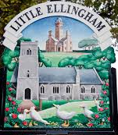
Little Ellingham News

Published by Little Ellingham Parish Council
Issue 68 – September 2021

Parish Council Meetings

The next meeting of the Council will be on Wednesday 3rd November 2021 at Old School Hall, beginning at 7.30pm. Parishioners are welcome to attend all Council meetings, where they are allowed to speak, but only during the Open Forum, which is for a short time usually at the start of the meeting. Look out for the agenda displayed during the previous week.

Your Parish Council Needs You!!!

It is with regret that we sadly have a vacancy on the Parish Council, thus meaning that we are in need of a new councillor to join our team. If this is something you wish to explore please contact the Parish Clerk or the Chairman for more information.

Jo FitzGerald’s London Marathon

Jo FitzGerald is running the London Marathon and is fundraising for Blood Cancer UK, and she’d really appreciate your support.
You can donate to her JustGiving page by clicking here: https://www.justgiving.com/fundraising/jo-fitzgerald1?utm_source=Sharethis&utm_medium=fundraising&utm_content=jo-fitzgerald1&utm_campaign=pfp-email&utm_term=2d62e122dffb4634987f4e68380db0a1.
Donating through JustGiving is simple, fast and totally secure. Once you donate, they'll send your money directly to Blood Cancer UK, so it's the most efficient way to give - saving time and cutting costs for the charity.
Thank you in advance

Mardle

Good news Mardlers! The Mardle is now meeting again on Thursday mornings10.00 – 12.00. We are currently meeting in the Church, but hopefully we will soon be back in the Village Hall. Come and join us for coffee/tea and nibbles. And of course, a good old chat!

We look forward to seeing everyone once again and look forward to welcoming new faces too. All welcome and see you there.

St. Peter’s Church Coffee and Cake Morning

St. Peter’s Church is holding a coffee and cake morning on 25th September between 10am and 12 noon in the Church.

All are welcome and all money raised with go to MacMillan Cancer Support.

Any donations of cakes will also be greatly received. Please contact Margaret Thomas on 01953 453455.

Dogs in the countryside, Farmland and Little Ellingham
- Keep your dog under close control.
- You and your dog should both keep to the line of the path.
- Always carry a dog poo bag and clean up after your dog both in the countryside and on pavements. Fouling is illegal, including in the Churchyard and the Common!
- Please keep your dog on a lead when livestock are in fields.

Kerry Foods Complaints Process

It is important that any parishioners who experience an issue with the
Kerry Foods operation, report their concerns on the phone number
previously communicated (01953 852600).

These complaints are logged by Kerry Foods and reviewed by
Breckland Council to understand the impact on our local community.
It also ensures that Kerry Foods and your Parish Council can address
the issues which are important to our parishioners.

We know that some parishioners also email Paul Dauny at Kerry
Foods with issues and this route can also be used to log any concerns
at Paul.Dauny@kerryfoods.co.uk

To ensure the Parish Council has full visibility of concerns raised, we
would ask that you email a brief summary of the issue to the Parish
Clerk or Chairman on the following email addresses. We are keeping
a record of all complaints which we will use to discuss and follow up
actions with both Kerry Foods and Breckland Council.
Parish Clerk – little.ellingham@gmail.com
Chairman – peter.griffiths@afiweb.net

The Queens Platinum Jubilee 2022

In June 2022, the United Kingdom will once again be in the spotlight around the world while we raise a glass in celebration of Her Majesty Queen Elizabeth’s 70th Year Reign. The May Bank Holiday has been moved and extended to Thursday 2nd June 2022 and with an extra Bank Holiday on Friday the 3rd of June where we will enjoy a nationwide 4-day celebration to include splendour and pageantry like only the British know how.
Our Royal Jubilee events are synonymous with street parties and gatherings up and down the country, friends and neighbours will get together to enjoy this historic event and to show support and thanks for our Monarch Queen Elizabeth II. The Platinum Jubilee is set to be even more extraordinary than the Diamond Jubilee and that was spectacular. We can expect to see creative displays within the Royal Household along with the latest digital technological displays that have since evolved.

The Parish Council would like to hear your thoughts on how we can celebrate this momentous occasion and as always is also looking for volunteers.

Defibrillator and CPR Training

Our village is fortunate enough to have a defibrillator machine fitted on the
outside wall of the Village Hall.

The emergency services have it registered there. So, if you dial 999 and
describe someone with chest/heart related issues they may direct you or
someone else to go and get it. It’s super easy to use but could seem daunting
if you haven’t used one before.

On 29th September at 6pm at the Village Hall we have a 2-hour training session
on how to use the machine and perform CPR.

This is free to parishioners but due to a limit of numbers in the hall it would be
appreciated if you could inform the Clerk of your attendance by 27th
September.

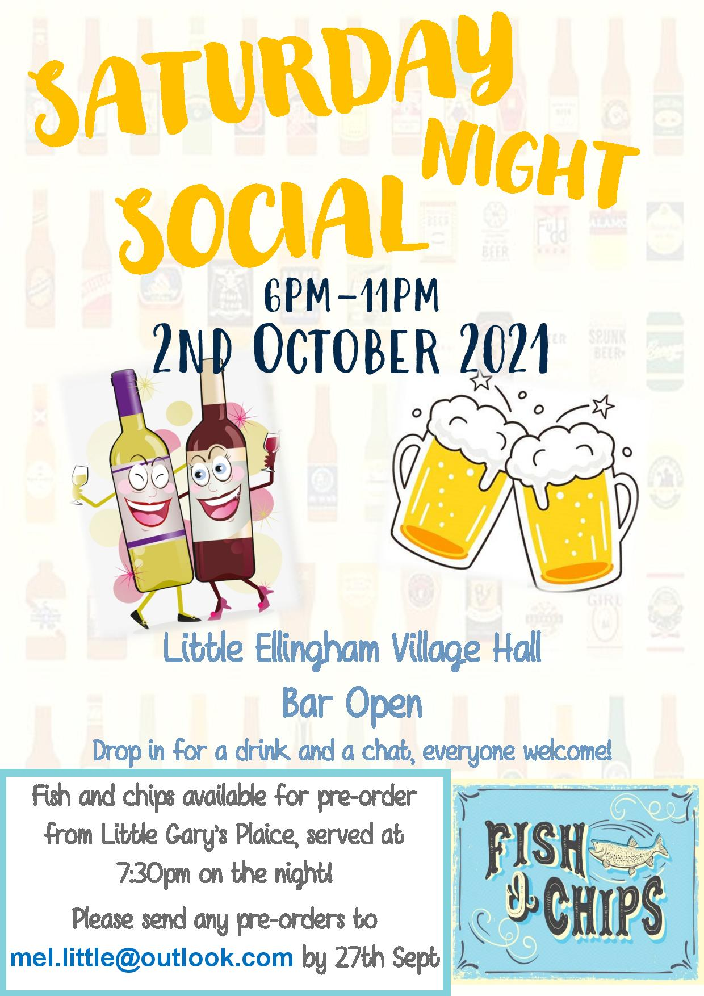
Little Ellingham Parish Council Chairman’s Report 1st May 2021

This past year has been quite a year! The Covid-19 pandemic has caused suffering across the county and the numerous lockdowns has caused so many difficulties for residents of the parish, whether the struggle to get essentials from the shops, medication or the isolation from friends and family. The pandemic has brought out the best of our community. In March 2020 we quickly formed a team of volunteers who have helped others doing shopping and picking up medication from the surgery or chemist. The village Facebook page has been full of offers of plants, fresh fruit and veg and various household items to recycle. The Parish Council would like to give thanks to all those volunteering to help our community. We know that not everyone has been able to help yet which hopefully means that we have loads of great informal arrangements in place supporting residents. We also wish to thank Scott and Paul and the wider team at Kerry Foods who provided us with number of food packages for residents. We know that these were very much appreciated by recipients.

It is regret that Sarah Drewery, Simon Atherton and Caroline Rebisz have resigned from the Parish Council. We would like to thank them for all the support and input they have given over the last year, especially Caroline who has been a very effective and hardworking chairman with the best interests of Little Ellingham always at the front of her mind. We’re also delighted that Sarah will continue to lead the Village Hall Committee. We now have a vacancy on the council so please get in touch with any of our councillors or Melanie if you are interested in joining us.

The Parish Council agreed that the Clerk should work towards the Foundation and Quality Award of the Local Council Award Scheme. This scheme offers councils the opportunity to show that they meet the standards set by the sector, assessed by their peers, and to put into place the conditions for continued improvement. The Foundation and Quality Award demonstrates that the council achieves good practice in governance, community engagement and council improvement.

The Council approved a precept of £4,500.00 for the year thus meaning that it has been increased by £100.00. For a band D property this equates to an increase of 66 pence per annum for the Parish Council’s part of your council tax.
The Parish Council submitted a successful bid to the Norfolk County Council Parish Partnership Scheme for 2021/2022 to purchase and erect a village gateway on the Attleborough Road.

